**Challenge 3 - Customer Insights**

**Introduction**

You are a Customer Insights Analyst for 'The General Store'

Can you analyse the following tables to find out crucial information about your customers to provide to your marketing team?

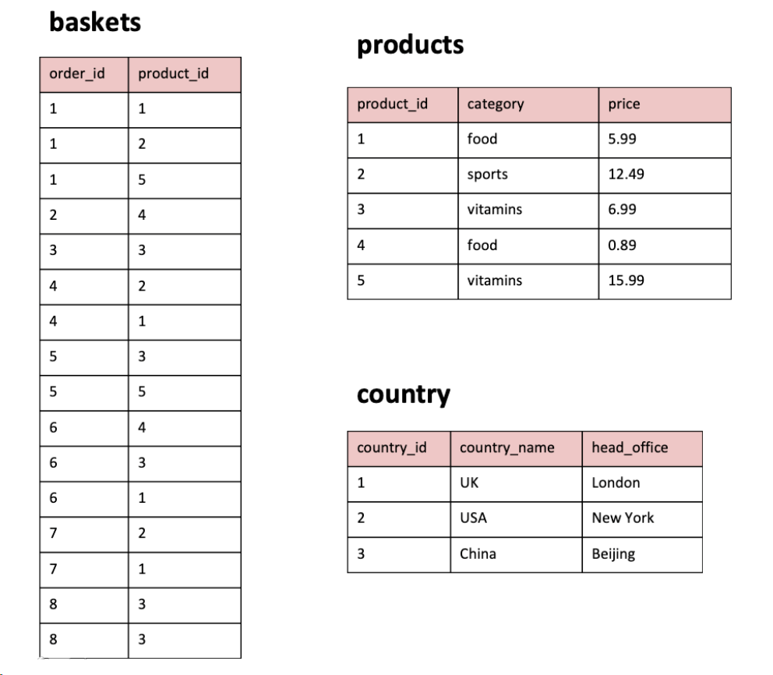

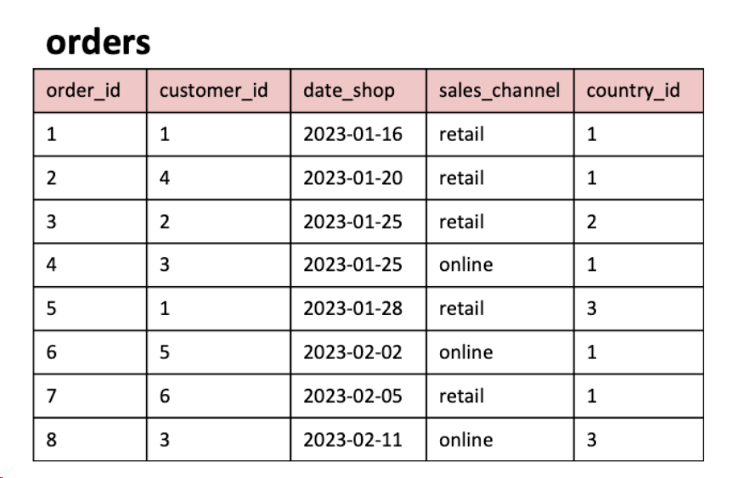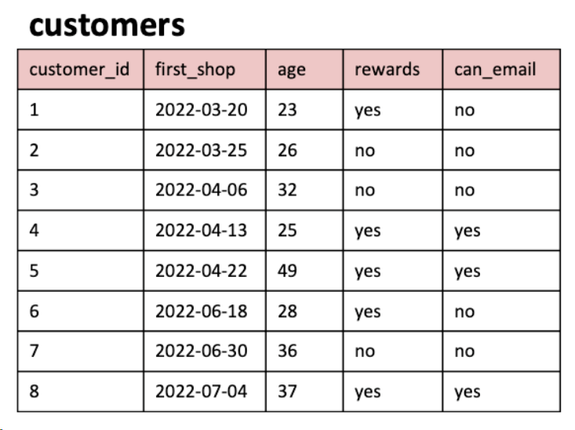

**Answer the following questions**

1. What are the names of all the countries in the country table?

2. What is the total number of customers in the customers table?

3. What is the average age of customers who can receive marketing emails (can_email is set to 'yes')?

4. How many orders were made by customers aged 30 or older?

5. What is the total revenue generated by each product category?

6. What is the average price of products in the 'food' category?

7. How many orders were made in each sales channel (sales_channel column) in the orders table?

8.What is the date of the latest order made by a customer who can receive marketing emails?

9. What is the name of the country with the highest number of orders?

10. What is the average age of customers who made orders in the 'vitamins' product category?

**DDL Commands**

CREATE TABLE country (

country_id INT PRIMARY KEY,

country_name VARCHAR(50),

head_office VARCHAR(50)

);

--------------------

INSERT INTO country (country_id, country_name, head_office)

VALUES (1, 'UK', 'London'),

(2, 'USA', 'New York'),

(3, 'China', 'Beijing');

--------------------

CREATE TABLE customers (

customer_id INT PRIMARY KEY,

first_shop DATE,

age INT,

rewards VARCHAR(50),

can_email VARCHAR(50)

);

--------------------

INSERT INTO customers (customer_id, first_shop, age, rewards, can_email)

VALUES (1, '2022-03-20', 23, 'yes', 'no'),

(2, '2022-03-25', 26, 'no', 'no'),

(3, '2022-04-06', 32, 'no', 'no'),

(4, '2022-04-13', 25, 'yes', 'yes'),

(5, '2022-04-22', 49, 'yes', 'yes'),

(6, '2022-06-18', 28, 'yes', 'no'),

(7, '2022-06-30', 36, 'no', 'no'),

(8, '2022-07-04', 37, 'yes', 'yes');

--------------------

CREATE TABLE orders (

order_id INT PRIMARY KEY,

customer_id INT,

date_shop DATE,

sales_channel VARCHAR(50),

country_id INT,

FOREIGN KEY (customer_id) REFERENCES customers(customer_id),

FOREIGN KEY (country_id) REFERENCES country(country_id)

);

--------------------

INSERT INTO orders (order_id, customer_id, date_shop, sales_channel, country_id)

VALUES (1, 1, '2023-01-16', 'retail', 1),

(2, 4, '2023-01-20', 'retail', 1),

(3, 2, '2023-01-25', 'retail', 2),

(4, 3, '2023-01-25', 'online', 1),

(5, 1, '2023-01-28', 'retail', 3),

(6, 5, '2023-02-02', 'online', 1),

(7, 6, '2023-02-05', 'retail', 1),

(8, 3, '2023-02-11', 'online', 3);

--------------------

CREATE TABLE products (

product_id INT PRIMARY KEY,

category VARCHAR(50),

price NUMERIC(5,2)

);

--------------------

INSERT INTO products (product_id, category, price)

VALUES (1, 'food', 5.99),

(2, 'sports', 12.49),

(3, 'vitamins', 6.99),

(4, 'food', 0.89),

(5, 'vitamins', 15.99);

--------------------

CREATE TABLE baskets (

order_id INT,

product_id INT,

FOREIGN KEY (order_id) REFERENCES orders(order_id),

FOREIGN KEY (product_id) REFERENCES products(product_id)

);

--------------------

INSERT INTO baskets (order_id, product_id)

VALUES (1, 1),

(1, 2),

(1, 5),

(2, 4),

(3, 3),

(4, 2),

(4, 1),

(5, 3),

(5, 5),

(6, 4),

(6, 3),

(6, 1),

(7, 2),

(7, 1),

(8, 3),

(8, 3);